Date 25-03-2024

Optional Handson:VPC +EC2, EBS, AMI – 24/03/2024 -IP Mahesh

What we cover in Last Session

We have done in last session

Now Todays Session

CLI ( command Line Interface) we will do for Linux Machine .

Install Mobaxterm

Download the portable edition

Install in my Laptop

Now Launch Linux EC2 Instance

For Pricing it is very important

Only Choose T2mmicro AMI

Download redhat Keypair

Keypair is a private key holding first time password. Till resetting the password

Edit network settings

Disable public IP , verify Security group

It should be on port 22 SSH

Click on launch Instacne

Public IP is disabled hence not showing.

Forgot the Public IP to enable.

No way to enable the public IP

Go the Elastic IP

Check EC2 Availability zone first allocating the Elastic IP

Click on Allocate

Elastic IP pls allocate to EC2 instance immediately other wise it will be charged

Public IP and Elastic IP both are coming from AWS open pool .

Now Try login to the AWS Console

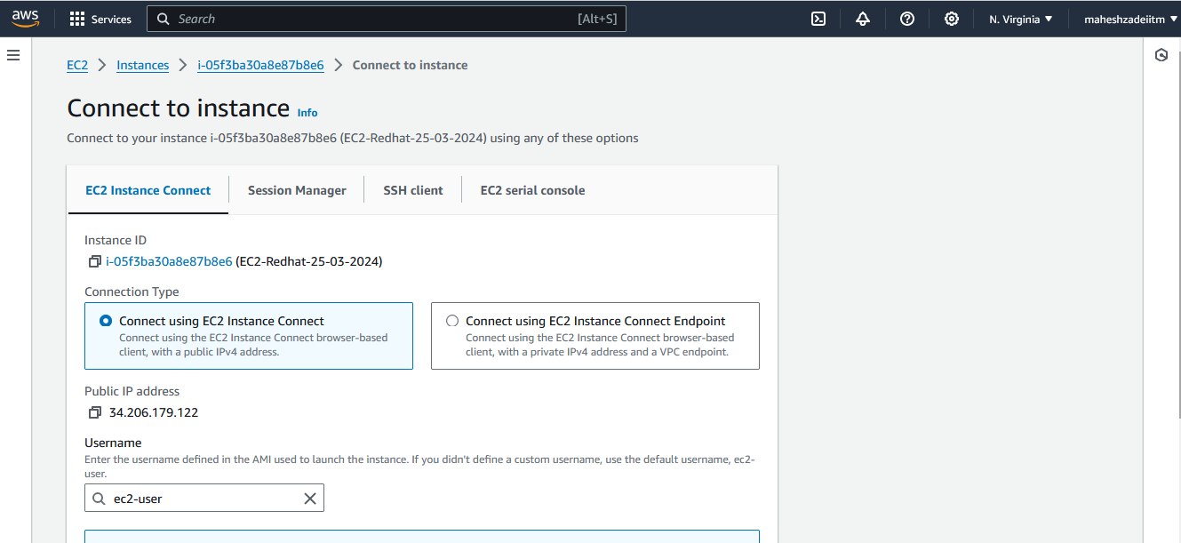

Unbale to connect in N Virginia

Giving error